Project:
Certified Training for Engineers and Technicians in Design and Installation of Grid Connected Photovoltaic Energy Systems

CASE STUDY: ESTABLISHMENT OF RENEWABLE ENERGY CERTIFICATION and ACCREDITATION SCHEME.

October 2014

Report Prepared for:

The Establishment of Renewable Energy Certification and Accreditation Scheme in the Pacific Islands

Renewable energy (RE) and energy efficiency (EE) have long been identified as priorities and necessities for the Pacific Island Countries and Territories (PICTs). Over the past 20 years, training and use of RE and EE throughout the PICTS has been deployed typically on a project basis with little or no information or technical support to ensure some long-term success for these initiatives. Whilst the Pacific Power Association (PPA) oversees and represents the operation and interests of power utilities and larger corporate interests, small business is not included as part of the PPA.
The Sustainable Energy Financing Project (SEFP), funded by the Global Environment Facility Trust Fund, was administered by the World Bank in Fiji, Papua New Guinea and The Solomon Islands. One part of this project included conducting solar training courses in the three countries. In 2008/09, while conducting these training courses, Global Sustainable Energy Solutions Pty Ltd (GSES) was approached by key industry stakeholders indicating that there was an ever increasing need for a technician certification/accreditation scheme similar to that operating in Australia.
It was agreed that a sustainable energy industry association would be the preferred vehicle to orchestrate and manage this scheme. The Sustainable Energy Industry Association of the Pacific Islands (SEIAPI) was conceived.
At that time, as there was no certification program for designers and installers of RE systems or energy auditors for EE, the outcome proposed for SEIAPI was the development of:
- SEIAPI as the industry association to represent the interests of industry (private and semi-government) providing goods and services to the public.
- The certification program for technicians/auditors working in the industry.

At this time in 2009, it was known that a funding cycle from Renewable Energy & Energy Efficiency Partnership (REEEP) was available. GSES, having worked in the PICTS since 2005, was aware of the SEFP research, the training and certification requirements of RE and EE in these regions, and the REEEP funding.
With the collaboration and support of PPA, SPC, USP etc., GSES oversaw the development of the concept for the establishment of SEIAPI and the project inception discussions with PICTS’ government, semi-government, education facilities and industry.
The project titled: Establishment of the Pacific Islands Sustainable Energy Industry Association and Certification Scheme, was awarded funding by REEEP for the identified outcomes and reporting obligations. The primary indicators of the successful application of this funding for the realization of SEIAPI would be:
- The establishment and successful operation of SEIAPI within the region;
- The operation of the SEIAPI Certification Scheme within the region;
- The acceptance of the SEIAPI Certification Scheme within the region;
- The majority of known businesses/companies in the industry to be members of SEIAPI;
- For each SEIAPI member, at least one staff member is certified under this scheme (or applying to be certified)

Under the REEEP project, workshops were held in Fiji and Pohnpei with industry players, government, and utilities to discuss the formation of SEIAPI and the proposed certification program. Following these 2 workshops, there was continuing discussion about where best to locate the SEIAPI office. Suggested at that time was Guam and Fiji and the possibility of co-sharing existing office space with a like-minded organisation. The workshops considered the technical outcomes for training based on Australian/New Zealand standards and practices compared to the US based requirements for the north Pacific.
Subsequent discussions and meetings with industry and utilities, it was agreed that competency standards were required to support any certification provided to industry players. An advisory board was duly established to oversee the training materials, practical course structure and proposed delivery methods.
SEIAPI was subsequently founded in November 2010 and the scheme was launched on May 18, 2012, in Suva as part of the rollout of the UN Year of Sustainable Energy for All. By this time, SEIAPI’s guidelines for grid-connect solar systems, stand-alone power systems and hybrid power systems had been developed and were available to the industry. The guidelines and the competency standards for the design and installation of grid connect solar systems were launched at the same time as SEIAPI.
To realize the potential of SEIAPI, the PICTS’ RE industry needed locations where the training for grid connect solar systems could be conducted. GSES, as a private Registered Training Organisation (RTO) in Australia providing training for the design and installation of grid connect solar systems, offered SEIAPI’s and PPA’s members access to its online learning materials at a discounted cost for this course and to complete this training by having GSES travel to the 5 PICTS to deliver the practical face-to-face training.
IRENA, being aware of SEIAPI’s achievements to date, offered to fund the delivery of the practical training component for the grid connect solar course in 5 Pacific Island countries.
In 2012, discussions between PPA and SEIAPI resulted in the signing of an MOU between these organisations to work collaboratively for the development and delivery of standards and guidelines and in 2014 this was expanded to include the industry certification scheme.
In April 2014, SEIAPI/PPA released its Certification and Accreditation Scheme, which includes provision for certification as i) designers; ii) installation (maintenance) technicians; iii) energy efficiency auditors; and iv) inspectors (of system installations). The organisation (or business entity) can be accredited as the supplier of products, systems and services. Individuals operating as sole traders within the industry, for example selling and installing RE equipment or acting as an energy efficiency auditor, must apply to be both a certified individual and an accredited organisation.
The SEIAPI competency standards were developed by the Renewable Energy & Energy Efficiency Training Competency Standards Advisory Committee. This committee is chaired by the University of South Pacific and includes the following initial members:
a. SEIAPI (one representative from executive and GSES as secretariat)
b. Pacific Power Association (PPA)
c. Secretariat for Pacific Community (SPC)
d. United Nations Development Programme (UNDP)
e. Secretariat of the Pacific Regional Environment Programme (SPREP)
f. College of Micronesia (COM-FSM)
g. International Union for Conservation of Nature (IUCN)
h. Guam Community College (GCC)
The SEIAPI program has two levels of certification/accreditation: provisional and full. An individual will need to successfully complete a training course which has been recognised (and or specified) by SEIAPI/PPA. As the certification/accreditation program is an industry-based program, SEIAPI/PPA wants to confirm that the individual is actually incorporating into their work what they have learnt in such a training course. Therefore both levels of membership, i.e. (i) the individuals and (ii) the organisations, will initially receive ‘provisional’ certification/accreditation after successfully completing the training. Full Certification would be provided after they submit evidence that they have applied the training received in their work.
SEIAPI certification/accreditation is offered for individuals and organisations whether they are SEIAPI members or not. The Accreditation and Certification offered by SEIAPI are governed by the following rules:

Individuals
  - Provisional certification is valid for a maximum of one (1) year. If, at the end of one (1) year, the individual is unable to present three (3) case studies, then the individual can apply for an extension at the discretion of SEIAPI/PPA.
  - Once fully certified, the individual is accredited for a period of three (3) years and must renew every three (3) years following the specified renewal process. This includes providing a statement of what professional development activities have been undertaken.
  - The individual must abide by all technical guidelines and standards that apply to their particular discipline and technology. Failure to follow these guidelines could result in the certification being suspended or revoked.
  - The individual must abide by the code of ethics.

Organisations
- Provisional accreditation is valid for a maximum of one (1) year. If, at the end of the one (1) year the organisation does not have fully certified individuals in the relevant disciplines and technologies, then the organisation can apply for an extension at the discretion of SEIAPI/PPA.
- Once fully accredited, the organisation is accredited for a period of three (3) years and must renew every three (3) years following the specified renewal process.
- If at any time the organisation does not have, either as a staff member or sub-contractor, the relevant certified individual for their particular technology and application then the organisation must notify SEIAPI/PPA immediately and the accreditation will be suspended until the company has access to appropriately qualified individuals.
- The organisation must abide by SEIAPI/PPA’s industry best practice guidelines. Failure to follow these guidelines could result in the certification being suspended or revoked.
- The organisation must abide by the code of ethics.

SEIAPI have available the following documents to support the association’s outcomes:
- Eligibility rules for applying - certified Individual
- Eligibility rules for applying – accredited business
- Approved Courses
- Rules for the SEIAPI/PPA Certification and Accreditation Scheme
- The procedures for renewal.
- Codes of Ethics
- SEIAPI/PPA Industry Best Practice Guidelines

The technologies identified by SEIAPI include:
- PV Grid connect systems
- Stand Alone PV Power systems
  - Level 1- Solar Home Systems
  - Level 2- Stand alone systems with/without Inverters
  - Level 3- Hybrid Power systems
- Wind Systems
- Energy efficiency
- Biomass Systems

Over the past 4 years, SEIAPI has grown to a membership of 65 members: 32 industry members, 15 associate members and 18 honorary members. There are currently 50 people undertaking the grid connect training as a pathway to certification.
The current combination of online theory training and face-to-face practical training was seen as an acceptable compromise between (i) the delivery of all material face-to-face for which the time demands are excessive for businesses and their technicians and (ii) having no assurance when a suitable training program could be available for SEIAPI to administer and certify. One assumption made was that any practical training delivered would have access to suitable training systems to ensure that practice and information was provided on the range of possible system configurations and types.
The IRENA funded training courses were held in the following locations:
Apia, Samoa 13-15 May 2014 No. Students: 10
Betio, Kiribati 3-6 June 2014 No. Students: 7
Betio, Kiribati 6-11 June 2014 No. Students: 13
Tongatapu, Tonga 9-12 September 2014 No. Students: 6
Suva, Fiji 25-28 November 2013 No. Students: 9
Majuro, RMI 1-4 September 2014 No. Students: 4

These training courses had as their objective to revise the main theoretical content of the Grid Connected Solar: Design and Installation course and to also provide the following practical components:
- Installation of a grid-connected PV system
- Commissioning of a grid-connected PV system
- Fault finding in a grid-connected PV system
All participants at these practical courses were found to be competent in the required tasks. Although having successfully completed the practical component of this certification course, these 49 students must also complete the online course material, an exam, and a System Design Task before being eligible for their certification.
The following table summarises the number of accreditations and certifications awarded as at the time of writing this case study:
Accreditation & Certification PROGRESS
Number of students who have obtained certificates from GSES | Number of students who have obtained SEIAPI Accreditation | Number of companies with SEIAPI Accreditation
12 | 7 | 2

Agenda for the Practical Courses delivered
Proposed Fiji course schedule - 6 to 16 students
 | Day 1 |  | Day 2 |  | Day 3 |  | Day 4
 | Group 1 | Group 2 | Group 1 | Group 2 | Group 1 | Group 2 | Group 1 | Group 2
8:00 | Intro and safety orientation |  | Mount brackets and rails | Complete Workbooks | Dismantle systems | Dismantle systems | Fault finding and individual commissioning
8:30 | Slides 10 - 26 (position of sun, temperature effect) |  |  |  | Complete Workbooks | Mount brackets and rails
9:00 | Slides 27-34 (bypass diodes, wind loading)
9:30 | Slides 35 - 43 (system yield)
10:00 | Slides 62 - 82 (functional earthing, earthing modules) |  |  |  |  |  | Slides 118 - 128 (voltage rise)
10:30 | Morning tea |  | Morning tea |  | Morning tea |  | Morning tea | Morning tea
11:00 | Solar pathfinder and site assessment | Solar pathfinder and site assessment | Continue installation - mount modules and inverter | Complete Workbooks | Complete Workbooks | Continue installation - mount modules and inverter | RISE videos, protection & disconnection examples
11:30
12:00 |  |  |  |  |  |  | Software tools
12:30 | Lunch |  | Lunch |  | Lunch |  | Lunch | Lunch
13:00 | Slides 44 - 51 (matching array and inverter) |  | Complete installation and commission | Complete Workbooks | Complete Workbooks | Complete installation and commission | Additional Exercises if Requested | Additional Exercises if Requested
13:30
14:00 | Slides 52 - 61 (inverter types)
14:30 | Slides 83 - 117 (array isolators, earthing modules)
15:00
15:30
16:00 | Complete workbook up to sign off sheets
16:30 |  |  | Dismantle systems | Dismantle systems
17:00

When GSES initially made the offer to SEIAPI members to conduct local practical courses within countries, the intention was that the attending SEIAPI members would be able to provide the necessary equipment to undertake the course. The first course, attended by participants from two SEIAPI member companies, was completed in this way. However having to organise the equipment for the other practical courses required considerable organisation and time by GSES staff. For the Kiribati courses, the GSES trainers actually had to travel with some of the required training equipment. It is critical for this type of training, i.e. online material plus practical components, to be successful in the Pacific islands that there is available at least one grid connect solar system suitable for training purposes in each PICT where these courses are conducted. This in-country equipment will be able to be used repeatedly for training additional engineering and technical resources.

RENEWABLE ENERGY CAPACITY BUILDING: ECONOMIC POTENTIAL
The IRENA report Renewable Energy Opportunities for Island Tourism (August 2014) considers the potential for renewable energy technologies to contribute to island tourism. One of the barriers identified and quoted in this report as a limit to the deployment of these technologies for this purpose is:
‘Institutional and technical capability (knowledge gaps)’.
This report also notes that one of the ‘four main policy tools’ to create the environment for the barriers to be overcome is:
‘Institutional and technical capacity building.’
The commentary in the quoted IRENA report refers to island tourism generically, so the PICTS’ experience may be on a varying scale in application. However, the major financial and environmental drivers for the uptake of renewable energy technologies exist and the commitment made by various PICTs means that the potential is now a reality with a time frame attached.
The potential for the broad use of renewable energy technologies in the Pacific region has been a commitment formalised by numerous PICTS. The following table summarises some current commitments to renewable energy by Pacific Island nations:
PICT | % Contribution of Renewable Energy to Power Requirements | To be achieved by which Year
Tuvalu | 100% | 2020
Tokelau | 150% | 2012
Cook Islands | ~80% | 2018
Fiji | ~100% | 2013
Solomon Islands | 50% | 2015
Federated States of Micronesia | 50% | 2012
Niue | 100% | 2020

The above table summarises the current and projected renewable energy usage in the PICTS for the next 15-20 years. As a reality, the amount of renewable energy as a source of reliable electricity for business, tourism and domestic use means that there are business and employment opportunities for its deployment. The obvious silent element in the economic discussion is how to ensure that all renewable energy power systems are able to be installed and perform according to specifications. This naturally leads back to the required training and certification. It is hoped that an organisation such as SEIAPI is able to support this vital industry’s development and also to provide ongoing information and technical professional development for its accredited alumni and its members.

CONCLUSIONS & RECOMMENDATIONS
The project has been a success with 49 people attending one of the six practical training courses conducted across 5 countries. Currently 12 participants have completed all the assessment and technical material: 7 of these participants have completed all assessments and been awarded their PPA/SEIAPI provisional certification, while 2 companies have applied for and received their accreditation.
The feedback (in the form on written questionnaires) from the course participants has typically been positive.
As stated previously, GSES finds that the course participants in Australia need up to 12 months to complete the online course material. Although it is preferable that the participants have completed at least 75% of the online material before attending a practical course, this is not necessarily feasible in the Pacific islands because the practical courses will have to be conducted at set times.
Having to conduct these practical training courses did emphasise the need for a complete grid connect solar system located in each country to be used for training purposes. This system equipment to be used for practical training will be dismantled and reinstalled many times as required by this training, so therefore the equipment must be good quality and will require periodic replacement. The cost of grid-connected solar systems has reduced dramatically over the past 3-5 years, and the equipment costs for such a training system would be between $5,000 and $10,000 per country. The system could either be located at the Utility or at a technical training centre.

Following is a summary of photos taken during each of the IRENA funded practical training courses as noted above.

Training Course conducted in Apia, Samoa: 13-15 May 2014.
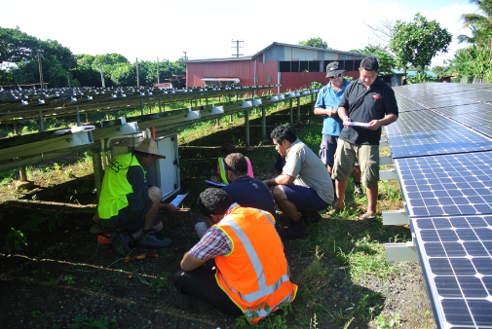

Candidates undertaking commissioning and faultfinding on a section of one of the local utility’s (EPC) solar systems.

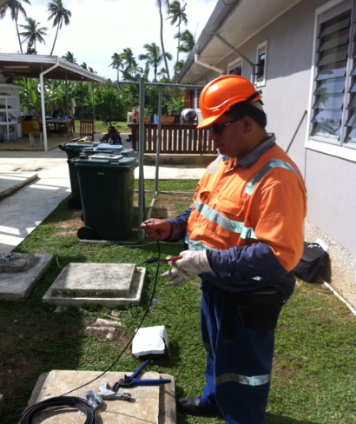
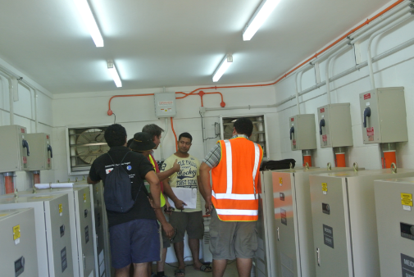
Candidates learning about the on site grid connect inverters, installation requirements, and troubleshooting.

Training Course conducted in Tongatapu, Tonga: 9 – 12 September 2014

Candidate preparing solar cabling for system installation
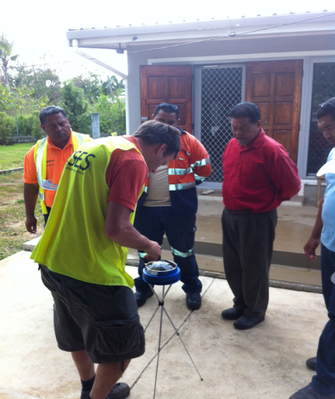
Candidates learning how to use the Solar Pathfinder to measure the shading at site.

Training Courses conducted in Betio, Kiribati: 3-6 June 2014 & 6-11 June 2014.

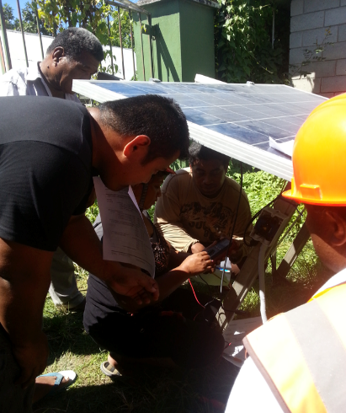

Candidates conducting commissioning and fault finding on solar array.

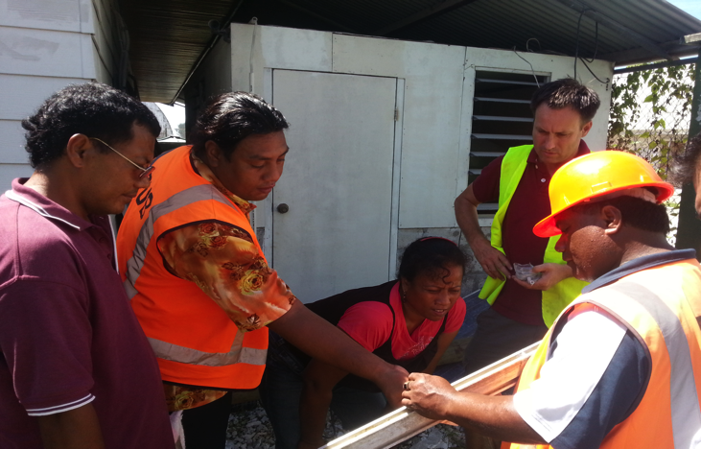

Candidates discussing the installation of the solar array’s mounting structure.

Training Course conducted at Majuro, RMI: 1-4 September 2014.

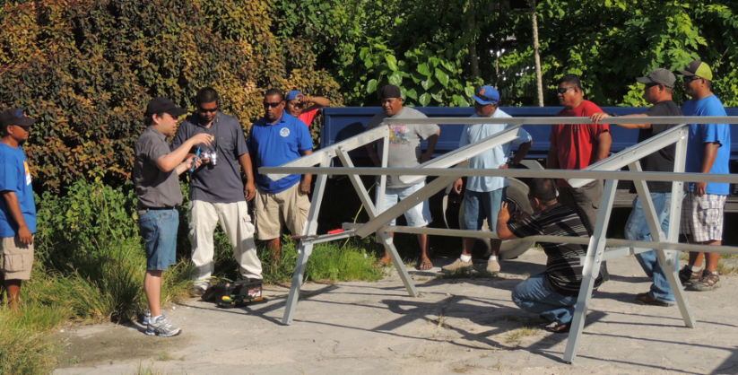
Training on the solar array’s mounting structure installation.

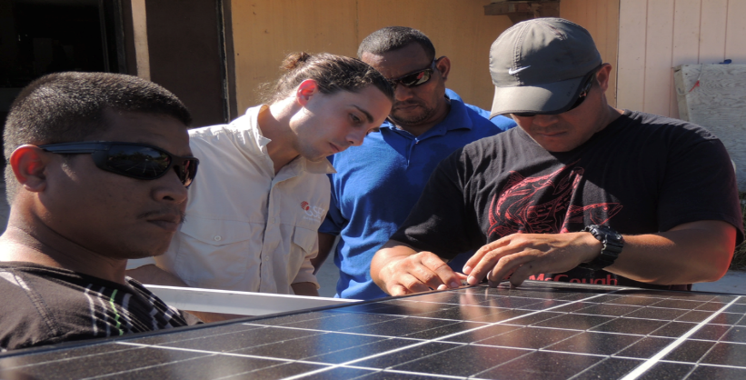
Installation of solar modules onto mounting structure.

Training Course conducted in Suva, Fiji: 25-28 November 2013.

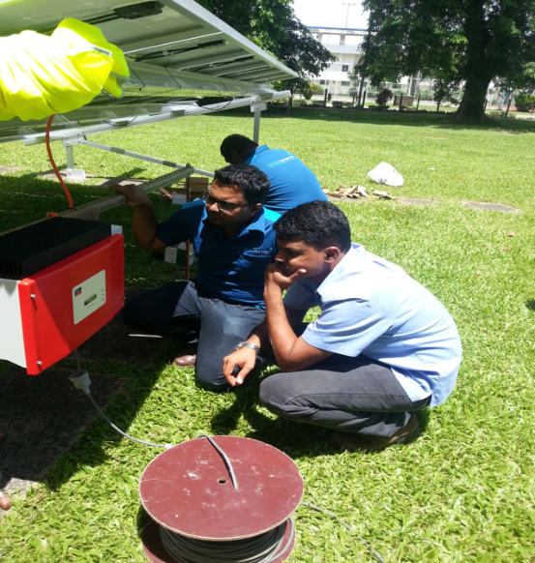
Candidates discussing the installation of the grid connected inverter.

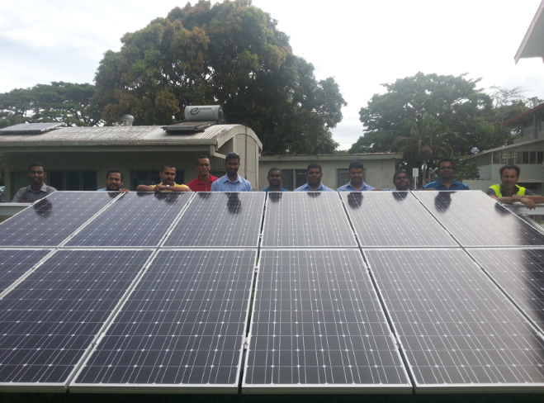
Solar array installation completed

