Project:
Certified Training for Engineers and Technicians in Design and Installation of Grid Connected Photovoltaic Energy Systems
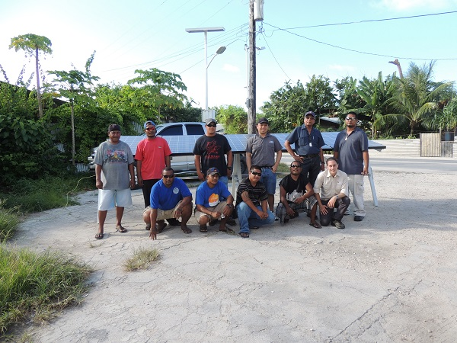

Final Report
Report Prepared for:

Contents
1.0 Introduction 1
2.0 Overview of Training Courses 2
3.0 Assessments 6
4.0 Survey Results 9
5.0 Ability to Upscale and Replicate this Training 10
6.0 Financial Report 11
7.0 Conclusions and Recommendations 12
Appendix 1: Course Registrations 13

Introduction
The Sustainable Energy Industry Association of Pacific Islands (SEIAPI) launched their scheme for the certification of technicians in May 2012. Following discussions with the Pacific Power Association (PPA), SEIAPI and PPA now jointly manage the scheme.
In order to facilitate the development of the certification program, in early 2013 GSES offered a discounted fee for SEIAPI and PPA members to undertake GSES’ design and installation grid connect solar online training course. To successfully complete this course, the students were required attend a 3-4 day practical training course. This course was conducted in country and paid for by the course participants.
IRENA offered funding support to the PPA and SEIAPI to conduct the practical course and related supporting activities. The project was known as the: Certified Training for Engineers and Technicians in Design and Installation of Grid Connected Photovoltaic Energy Systems.
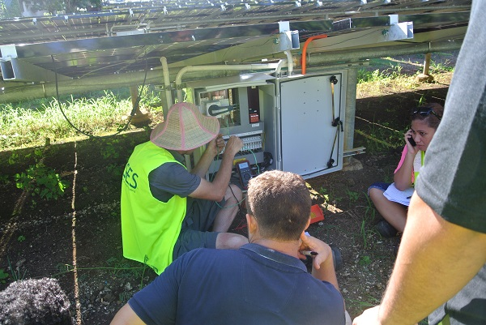
Figure 1: Trainer David Wilcher explaining commissioning methodology during the Course Conducted in Samoa.
A total of 62 people have registered to undertake the training course. Six (6) people subsequently withdrew thereby leaving a total of 56 people attempting the course. The full list of the 62 registered people including their contact details is provided in Annex 1.
Initially 2 people from Tuvalu registered to do the online course under this project. However the Tuvalu Electricity Corporation, under separate funding from SPREP, organised practical training courses for their staff at GSES’s training centre in Sydney. Therefore the revised course participants total was 54 who would attend practical training courses as part of this project.
Six training courses were conducted with a total of 48 attending. Six (6) people were unable to attend due to various reasons. One person from Samoa, who missed the in country course there, funded his own way to attend the equivalent course in Sydney. For the remaining five (5) people, if courses are not conducted in the region in the next 6 months, they will need to arrange travel to Australia and attend a course at GSES’ training centre.
At the time of writing this report, 10 people had successfully completed all the course assessments and had been awarded their provisional certification from PPA/SEIAPI. Nine of these participants were from two Fijian companies, Clay Energy and CBS Power, and each of these companies have applied and received their provisional accreditation. The tenth person is from Tonga.
A case study has been prepared which highlight this training initiative and includes: an overview of the development of SEIAPI; the PPA/SEIAPI certification and accreditation scheme; the development of competency standards and how this project has benefited the industry in the PICTS by facilitating the first people/companies in becoming certified/accredited.

Overview of Training Courses
The training course comprises an online component plus the 3-4 day face-to-face practical component. The online course components cover all the theoretical aspects of grid-connected PV systems. This material requires approximately 50 hours work to be completed. The information topics within the online course are sequential. The course participants must complete quizzes and written answers in each online course topic to a required level before being able to progress to the next topic.
Initially it was hoped that all course participants would finish their online component prior to attending their practical course and, due to the funding timeframe of the project, they were requested to complete the online material within 3 months. This time period was found to be unrealistically short. In Australia students are given 12 months to complete the online material and the practical course; and not all people will have completed the online material before attending the practical course. GSES has since applied the same format to this project’s course participants. The current status of all course participants is detailed in Section 3.
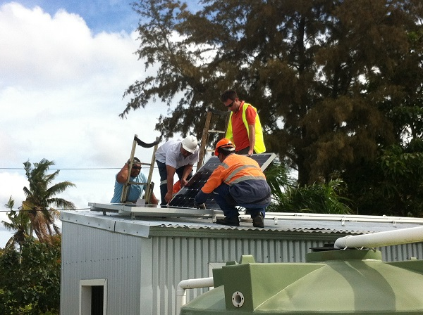
Figure 2: Participants Installing System in Tonga
Table 1 provides a summary of the six practical courses conducted. Table 2 lists those who attended each course, and Table 3 lists those who are registered but did not attend the practical course held in their country.
When GSES initially made the offer to SEIAPI members to conduct local practical courses within countries, the plan was that the attending SEIAPI members would be able to provide the necessary equipment to undertake the course. The first course, attended by participants from two SEIAPI member companies, was completed in this way. However having to organise the equipment for the other practical courses required organisation and time by GSES staff. For the Kiribati courses, the GSES trainers actually had to travel with some of the required training equipment. It is critical for this type of training, i.e. online material plus practical components, to be successful in the Pacific islands that there is available at least one grid connect solar system suitable for training purposes in each country where these courses are conducted.

Table 1: Summary of Courses
Course Number | Country | Date Held | Number of Attendees | GSES Trainers
1 | Fiji | 25th to 28th November 2013 | 10 | David Wilcher  Reneil Sabater
2 | Samoa | 13th to 15th May 2014 | 10 | Susan Neill  David Wilcher
3 | Kiribati | 3rd to 6th June 2011 | 7 | David Wilcher  Reneil Sabater
4 | Kiribati | 6th to 11th June 2014 | 11 | David Wilcher  Reneil Sabater
5 | Republic of Marshall Islands | 1st to 4th September 2014 | 4 | Reneil Sabater  Aaron Bonanno
6 | Tonga | 9th to 12th September 2014 | 6 | David Wilcher  Chris Martell

Table2: List of Attendees at Each Course
Practical Course | First Name | Surname | Company
Fiji | Ravinesh | Chand | CBS Power Fiji
 | Kinivuwai | Koroi | Clay Engineering
 | Praneel | Kumar | Clay Engineering
 | Jone G | Lalabalavu | Solar & Alternative Eng Supplies Fiji
 | Sylvian | Permal | CBS Power Fiji
 | Krishneel | Prasad | CBS Power Fiji
 | Amit | Singh | CBS Power Fiji
 | Aman | Singh | Clay Engineering
 | Mohammed | Tazil | Clay Engineering
 | Jason | Valentine | CBS Power Fiji
Samoa | Iose | Gray | Electric Power Corp
 | Nuulopa | Hill | Electric Power Corp
 | Tavita | Leleimalefaga | Electric Power Corp
 | Moeona | Leo | Electric Power Corp
 | Petaia | Mafulele | Electric Power Corp
 | Sione | Mateo | Electric Power Corp
 | Michael | Oti | Electric Power Corp
 | Peni | Peni | Electric Power Corp
 | Iosefa | Talouli | Electric Power Corp
 | Lomaivitilevu | Tepa | Electric Power Corp
Kiribati First Course | Tavita | Airam | KSEC Ltd Kiribati
 | Eremwa | Akai | PUB Min Public Works Kiribati
 | Kaare | Batinana | PUB Min Public Works Kiribati
 | Tebukei | Betero | KSEC Ltd Kiribati
 | Kaete | Binoka | KSEC Ltd Kiribati
 | Beria | Oromita | MPWU Min Public Works Kiribati
 | Tika | Tanentoa | MPWU Min Public Works Kiribati
Kiribati Second Course | Tiaon | Aukitino | MPWU Min Public Works Kiribati
 | Kiriati | Birita | PUB Min Public Works Kiribati
 | Lokea | Itienang | MPWU Min Public Works Kiribati
 | Nawaia | Natuteka | PUB Min Public Works Kiribati
 | Mwaati | Oten | MPWU Min Public Works Kiribati
 | Ioata | Remon | PUB Min Public Works Kiribati
 | Teebwatia | Taakau | PUB Min Public Works Kiribati
 | Enoka | Tauma | PUB Min Public Works Kiribati
 | Tokitebwa | Tawita | KSEC Ltd Kiribati
 | Ubwaitoi | Teurakai | MPWU Min Public Works Kiribati
 | Miriam | Tikana | MPWU Min Public Works Kiribati
Republic of Marshall Islands | Ronnie | Bungitak | Marshalls Energy Co
 | Damien | Milne | Marshalls Energy Co
 | Michael | Note | Marshalls Energy Co
 | William R P | Schutz | Marshalls Energy Co
Tonga | Salesi | Ahokovi | Tonga Power Ltd
 | Paini | Lie | Tonga Power Ltd
 | Viliami | Ongosia | Tonga Power Ltd
 | Sione | Pongi | Tonga Power Ltd
 | Feao | Teutau | Kingdom Energy & Electrical Services TONGA
 | Paula | Tupou | Alpha Electrical Ltd TONGA

Table 3: List of those registered who did not attend the practical course conducted in their country.
Practical Course | First Name | Surname | Company
Fiji | Akhil | Singh | CBS Power Fiji
Samoa | Byron | Bartley
 | Seumanu Peter | Young | Young Energy Solutions Co Ltd
Kiribati | Kireua | Bureimoa | MPWU Min Public Works Kiribati
 | Bauro | Mikaere | PUB Min Public Works Kiribati
RMI | Francis | Takatsuki | Marshalls Energy Co
Note: Seumanu Peter Young attended a training course in Sydney.

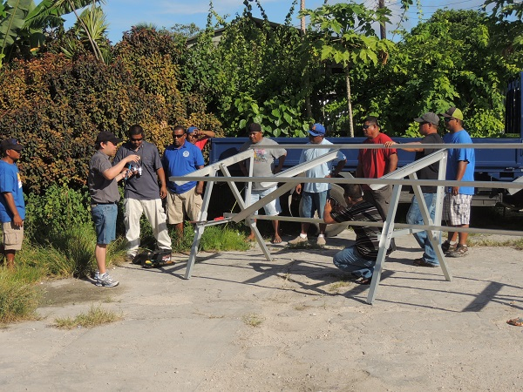
Figure 3: Participants erecting array frame in Marshall Islands.

Assessments
In order to successfully pass the course each course participant undertakes the following assessments:
- Online Assessments
There are 16 online quizzes that must be completed by the course participants as they progress through the online course.
- Final Design Task
The design task requires the course participant to produce two theoretical system designs using all of the information from this course. Full system sizing, diagrams, schematics, yield calculations and some basic economic assessments need to be made.

- Final Exam
The pass-mark requirement for the final exam is 90%. Total marks available in the final exam are 50. Although a 90% final exam may be seen as stringent, the final exam consists of 24 questions similar to the online quizzes where students must obtain 100%. The final exam is an open book, take home exam. Course participants have a two-week window to complete the exam and submit it to GSES either via post or email. This exam takes approximately 2 to 3 hours of their time. Failure to submit the final exam within that time results in an invalid final exam. Under these circumstances, the student will need to attempt an alternate final exam.
- Installation Assessment (conducted during practical course)
The installation assessments require the course participants to install and uninstall a grid-connected PV system. This involves proper installation practice, evaluating that the mounting system for the solar modules is stable and properly installed for the modules.
- Commissioning Assessment (conducted during practical course
The course participants must be able to commission a grid-connected PV system. This involves ensuring that the PV system can be switched on. Values need to be recorded on the commissioning sheets and these correspond to the observations made during the commissioning. These values include open circuit voltages, short circuit currents and other checks that ensure that the system has been installed as per the established standards.
- Fault Finding Assessment (conducted during practical course)
The training electrician conducts the fault-finding assessment. He introduces a fault in the system and tests how proficiently the course participants identify and resolve the fault. This is the most time consuming part of the assessments, as each course participant must be assessed individually, whereas the installation and commissioning assessments are conducted as groups.

Survey Results
All participants at the conclusion of all the courses completed a survey. The survey changed after the first course in Fiji. Table 5 shows the averaged results for the survey conducted at the Fiji training while table 6 shows the average results from the surveys from the 5 other courses. The results ranged from ‘5’ corresponding to “Completely Agree” to ‘1’ corresponding to “Completely Disagree”. The actual participants results was provided in each training report.
The survey included provision for the participants to comment on the course.
Table 5: Averaged Results from Fiji Survey
Feedback Question | Average Result
The trainers were understandable and answered questions to a satisfactory level | 4.7
The trainers maintained a professional attitude throughout the course | 4.9
The trainers had a firm understanding of the content | 4.8
The resources provided by the trainers were used well during the course | 4.8

Table 6 :Averaged Result from Survey for the 5 other courses
Feedback Question | Average Result
 | Samoa | Kiribati Combined | RMI | Tonga | Overall
The trainers were well prepared | 4.9 | 4.9 | 5 | 4.8 | 4.9
The trainers communicated effectively | 4.6 | 4.9 | 4.5 | 5 | 4.8
The trainers explained complex issues well | 4.9 | 4.9 | 5 | 5 | 4.95
The trainers were responsive to the learning needs of the participants | 4.8 | 4.8 | 5 | 5 | 4.9
The trainers structured the subject matter well | 4.8 | 4.8 | 5 | 5 | 4.9
I learned a great deal from the trainers | 4.8 | 4.9 | 5 | 5 | 4.93

Ability to Upscale and Replicate this Training
This grid connected solar training, funded by IRENA, delivered by GSES and managed by SEIAPI/PPA, could be replicated many times in the Pacific by the following means:
- Continue to offer the theory tuition online in the Pacific Island Countries and territories with tutor support and marking as provided to date by GSES;
- Develop a focussed information program to ensure that local businesses, trades, utilities etc. are aware of the training programs and their delivery timeframe;
- Ensure that there is a reasonable lead-time between when the participants can commence the course, undertake the practical component and finalise all material. The fact that there was only one course offered, with the exception of the 2 in Kiribati, meant the single set of dates were not suitable for many intended participants;
- Ensure that there is suitable, practical training equipment available in the intended locations;
- Consider allowing suitable skilled trades-people to undertake some further training so that they become a technical and training resource for the industry in that location.
- Identify local training centres where the train-the-trainer courses for the practical material could be conducted for local trainers. In the future this facility could be used to conduct 2-week face-to-face courses as required. GSES is able to provide all the required material for this 2-week course, which could be licensed for use by these centres.
It could also be rectified in other regions by
- Continuing to offer the course theory online, so that the duration of the face-to-face course can be limited to the 3 or 4-day practical course. GSES would be able to deliver the required practical training as required and could present ‘train the trainer’ courses in identified countries outside of the Pacific region.

Conclusions and Recommendations
The project has been a success with 48 people attending one of the six practical training courses conducted across 5 countries. Currently 7 of these participants have completed all assessments and been awarded their PPA/SEIAPI provisional certification, while 2 companies have applied for and received their accreditation. The feedback from the course participants has typically been positive. GSES has sent constant follow-ups to the other registered participants to remind them to complete their outstanding assessments. GSES is also in communication with the 5 people who were unable to attend their practical courses to determine how this could be achieved in the future.
As stated previously, GSES finds that the course participants in Australia need up to 12 months to complete the online course material. Although it is preferable that the participants have completed at least 75% of the online material before attending a practical course, this is not necessarily feasible in the Pacific islands because the practical courses will have to be conducted at set times. In Australia, the practical courses are conducted every 4-6 weeks, but this would not be possible in the Pacific at this stage.
Having to conduct these practical training courses did emphasise the need for a complete grid connect solar system located in each country to be used for training purposes. The USP in Suva did have a possible system, however it was not suitable for practical training because it could not be dismantled and reinstalled, which is obviously what is required for these training outcomes. The cost of grid-connected solar systems has reduced dramatically over the past 3-5 years, and the equipment costs would be between $5,000 and $10,000 per system per country. The system could either be located at the Utility or at a technical training centre. GSES is planning to discuss how best to locate these training systems with SEIAPI and PPA and see what suggestions could be made.

